[Insert Your Logo]

[Insert Business Name]
Business Plan

[Your Name, Title]
Created on [Month, Year]

[Insert Address] [Insert Email Address]

Table Of Contents

Table Of Contents 2
Executive Summary 3
Company Description 4
Value Proposition 4
Unique Selling Proposition 4
Products and Services 5
Marketing Plan 6
Industry 6
Target Market 6
Market Trends 7
Company Advantages 7
Competitors 7
Marketing Strategy 8
Operations Plan 9
Product/Service Specifics 9
Customer Service and Support 9
Order Fulfillment and Logistics 9
Monitor and Analyze Performance 9
Industry Trends 10
Regulatory Compliance 10
Management and Personnel 11
Principal Members 11
Financial Statements 12
Sales Forecast (see Appendices) 12
Break-Even Analysis (see Appendices 12
Funding Request 13
Appendices 13

Executive Summary

Explanation: The Executive Summary is the most important part of your business plan. Often, it’s the only part that a prospective investor or lender reads before deciding whether or not to read the rest of your plan. It should convey your enthusiasm for your business idea and get readers excited about it, too.

Write your Executive Summary LAST, after you have completed the rest of the business plan. That way, you’ll have thought through all the elements of your startup and be prepared to summarize them.

The Executive Summary should briefly explain each of the below.

- An overview of your business idea (one or two sentences).
- A description of your product and/or service. What problems are you solving for your target customers?
- Your goals for the business. Where do you expect the business to be in one year, three years, five years?
- Your proposed target market. Who are your ideal customers?
- Your competition and what differentiates your business. Who are you up against, and what unique selling proposition will help you succeed?
- Your management team and their prior experience. What do they bring to the table that will give your business a competitive edge?
- Financial outlook for the business. If you’re using the business plan for financing purposes, explain exactly how much money you want, how you will use it, and how that will make your business more profitable.

Limit your Executive Summary to one or two pages in total.

After reading the Executive Summary, readers should have a basic understanding of your business, should be excited about its potential, and should be interested enough to read further.

After you’ve completed your business plan, come back to this section to write your executive summary on the next page.

Enter your Executive Summary here:

Company Description
[Insert Business Name] is a [insert legal structure] in [City, State].

Value Proposition
At [Insert Business Name], we believe that [insert your main belief]. Our mission is to provide [insert what you plan to provide]. Our goal is to be the [insert what the goal is for your business What makes you different?].

Unique Selling Proposition
At [Insert Business Name], one of our key differentiators is [insert what makes your products different and why your customers prefer you over the competition].

Products and Services
Explanation: Description of Major Products or Services Offered. thoroughly explained, itemized, pricing, shipping, delivery.

Example: Lawn Care Service Business: Products: Mowing, landscaping, pressure washing, excavating, fertilizing, aeration, and soil testing.

Example: Service Business: Products: Marketing strategy, advertising strategy, business growth consulting, digital marketing and social media training, google ads consulting.

Explain your products or services here:

Marketing Plan

Industry Trends
Example: The [insert your industry] industry is a growing market that is estimated to reach [$xxx,xxx,xxx] by [year], according to a report by [insert where you got the statistics from]. This growth is driven by increasing demand from consumers and [thoroughly explain why your industry continues to grow and its potential].

List your industry trends here:

Target Market
Explanation: You should be able to identify what your target audience(s) have in common and how they will benefit from your product or service. Use the suggestions below to determine who your customers are and where you might find them.

You may have more than one target customer group. For instance, if you sell a product to consumers (customers) through distributors, such as retailers (vendors), you have at least two kinds of target customers: the distributors (business to business - B2B) and the end users (consumers or customers - B2C).

[Fully explain your target audience and/or customer(s) and why they will benefit from your products. Create a demographic profile for each group that includes these items and more].

Enter the details here:

For Business to Consumers (BTC):
- Age
- Gender
- Geographic Location
- Needs and Interests
- Income Level
- Occupation
- Education level
- Pain Points/Problem to Solve

For Business to Business (BTB):
- Industry
- Location
- Size
- Buying Decision Makers
- Stage in business (startup, growing, mature)
- Annual Sales
- Pain Points/Problems to Solve

Market Trends
Example: Leveraging a national trend of rising homeowner age, our business plan targets local homeowners over XX years old, a demographic expected to reach XX% of the market within the next three years. This growing segment possesses disposable income and is likely to outsource lawn care due to time constraints or physical limitations. By focusing on convenience, high-quality service, and solutions tailored to their needs, our business can capture a significant share of this expanding market opportunity.
[Market Trend 1]: [Fully explain the trend and how it benefits the industry]

[Market Trend 2]: [Fully explain the trend and how it benefits the industry]

[Market Trend 3]: [Fully explain the trend and how it benefits the industry]

Competitors
[Competitor 1]: [Write a sentence or two explaining what they offer and include what you plan to do to compete with what they offer].

[Competitor 1]: [Write a sentence or two explaining what they offer and include what you plan to do to compete with what they offer].

[Competitor 1]: [Write a sentence or two explaining what they offer and include what you plan to do to compete with what they offer].

Marketing Strategy
Describe how you will grow the business

Example: Create a marketing strategy that includes social media marketing, search engine optimization (SEO), email marketing, and influencer marketing. The strategy should work on building brand awareness, driving traffic to the website, and increasing sales. It will include:
- Establish a Strong Brand Identity: Develop a brand that resonates with the target market and reflects the company's values and mission. This includes creating a brand name, logo, and website design that is visually appealing and easy to navigate.
- Build a Professional Website: Develop a website that is easy to use, visually appealing, and includes a secure platform. The website should include detailed product descriptions, high-quality images, and customer reviews to help customers make informed purchasing decisions.
- Build Social Media profiles that reflect the brand and are engaging and educational and drive traffic to our website.
- If appropriate, plan and implement and email marketing/remarketing campaign or hold special events.
- Develop and Maintain Relationships: Build relationships with customers, suppliers, and partners to foster loyalty, trust, and collaboration. This includes providing value-added services such as tips, tutorials, and discounts for repeat customers.

Describe how you plan to implement marketing to grow the business

Operations Plan

Customer Service and Support
Sample: Establish a customer service and support team that is responsive, knowledgeable, and helpful. This includes providing customers with detailed product information, assistance with product selection, and timely resolution of any issues or concerns.

Enter your description here.

Order Fulfillment and Logistics
Sample: Develop an efficient order fulfillment process that includes accurate and timely order processing, packaging, and shipping. This includes partnering with reliable shipping carriers and establishing clear policies and procedures for returns and exchanges. Include inventory, hours, equipment, and labor needs.

Enter your description here.

Monitor and Analyze Performance
Sample: Regularly monitor and analyze key performance metrics such as website traffic, conversion rates, sales, and customer satisfaction. Use this information to make data-driven decisions and continually improve the customer experience.
Enter your description here.

Regulatory Compliance
[Insert Business Name] operates with a [Insert required licenses] License issued in the State of [Insert State].

Management and Personnel

Principal Members
Sample: [Insert Name] is responsible for defining and communicating the company's vision, mission, and goals to all stakeholders. [Insert Name] is responsible for developing and implementing strategies to achieve those goals. [Insert Name] oversees the financial management of the business, including budgeting, forecasting, and managing cash flow. [Insert Name] is responsible for ensuring that the business is profitable and financially sustainable. [Insert Name] is responsible for building and leading a high-performing team, setting clear expectations, providing direction and support, and creating a positive work culture.[Insert Name] is responsible for overseeing the company's marketing and branding efforts, including product development, pricing, promotion, and distribution. Responsible for building and maintaining the company's brand reputation and image.

[Insert Name] — Owner/Owners
Insert your text here:

Sample: [Insert Name] is responsible for staying up-to-date with industry trends, best practices, and regulations related to the hair extension business. They should also cultivate relationships with industry stakeholders, including suppliers, customers, and competitors.[Insert Name] is responsible for ensuring that the company operates in a socially responsible and ethical manner, including promoting diversity, equity, and inclusion, minimizing environmental impact, and giving back to the community.

[Insert Name] — Employee(s)
Insert your text here:

Financial Statements

Sales Forecast (see Appendices)
Explanation: This sales forecast is based on the assumption that the [insert business type] business will steadily grow its customer base and increase its sales over time. Factors that could impact sales include market competition, changes in consumer demand, and changes in the economic environment. The sales forecast will be regularly reviewed and updated to ensure that it reflects changes in the business environment and accurately predicts future sales.

Summarize here:

The [Insert Business Name] Sales Forecast for Years 1-3:

Total Annual Sales for Year 1: [$xxx,xxx]
Total Annual Sales for Year 2: [$xxx,xxx]
Total Annual Sales for Year 3: [$xxx,xxx]

Funding Request
Example: We have been in operation for [xx] years and have seen consistent growth and customer satisfaction. We are now seeking additional funds to expand our business and take it to the next level. We are requesting [$x,xxx] to [Insert request 1], [Insert request 2], and [Insert request 3]. Our current revenue is [$xx,xxx], and we are projecting a growth rate of xx% over the next year.

Enter your funding request here:

Specifically, we plan to use the funds as follows:
- [Insert request 1]: We plan to invest [$x,xxx] to purchase [insert what you plan to use the funds for] to [explain how this purchase will benefit your business].
- [Insert request 2]: We plan to invest [$x,xxx] to purchase [insert what you plan to use the funds for] to [explain how this purchase will benefit your business].
- [Insert request 3]: We plan to invest [$x,xxx] to purchase [insert what you plan to use the funds for] to [explain how this purchase will benefit your business].

We believe that these investments will allow us to continue to grow our customer base and increase sales. We are confident that we have the team, experience, and resources to successfully implement these initiatives and drive strong returns for our investors.

Appendices
Explanation: Attachments may include financial statements, the marketing plan, any schematics of your product or business location, letters of endorsement, and other key documents that help you present your case. Additional documents that may be attached might be contracts, leases, purchase orders, intellectual property, key management résumés, market research data or other supporting documents and specialty certificates.

Profit & Loss Statement (Appendices)
Explanation: A profit and loss (P&L) statement is basically a report card for your business. It shows how much money you made (sales) and how much you spent (costs) over a certain time. The difference tells you if you made a profit (good!) or a loss (uh oh!). This helps you see if your business is doing well and where you can improve.

Break-Even Analysis (Appendices)
Sample: This break-even analysis shows that the [insert company type] company needs to sell xx units per year or generate [$xxx] in revenue to cover its fixed costs and break even. Any sales above this point will result in profit for the company. The break-even analysis is a useful tool for the company to make informed decisions about pricing, sales volume, and cost management in order to achieve profitability. You should summarize here.

Enter your Break-Even Analysis here.

Average selling price per unit: [$xxx]
Variable cost per unit: [$xxx]
Fixed costs: [$x,xxx] per year

Break-Even Point Calculation:
Contribution Margin = Selling Price - Variable Cost = xx - xx = xx
Break-Even Point (units) = Fixed Costs / Contribution Margin = xx / xx = xx units
Break-Even Point (revenue) = Break-Even Point (units) x Selling Price = [$xx] x [xx] = [$xxx]

Cost of Goods Sold (Appendices)
Explanation: The cost of goods sold (COGS) for a lawn care business includes the direct expenses used to complete lawn care services and the indirect expenses. Here are some typical examples:
- Supplies: Grass seed, fertilizer, weed killer, edging materials, mulch, etc.
- Fuel: Gasoline or diesel for lawn mowers, trimmers, and other equipment.
- Blades and trimmer line: These wear out regularly and need to be replaced.
- Water (if applicable): This can be a cost if your services involve watering lawns during droughts or using pressure washers.
- Marketing and advertising: Website, digital marketing
Note: COGS typically excludes fixed costs like equipment payments, rent, salaries, and insurance. These are considered operating expenses. A template appears elsewhere in the HUB Resources for download.


South Haven Region Business Hub
Business Plan Template

HELPFUL INSTRUCTIONS

Please delete the following instructional pages before submitting your business plan to anyone.
Delete the BLUE instructional prompts from the template as you fill in each section.

The Table of Contents will auto generate as long as you do not change the styles on the large or medium size headers. You can change the wording, just don’t alter the size manually.
Click the top right corner of the Table of Contents and the circle to update it as you go.

Writing a business plan gives you an opportunity to carefully think through every step of starting your company so you can better prepare and handle any challenges. You’ll also NEED a business plan to seek out financing from a local bank or credit union, or even a crowdfunding campaign.
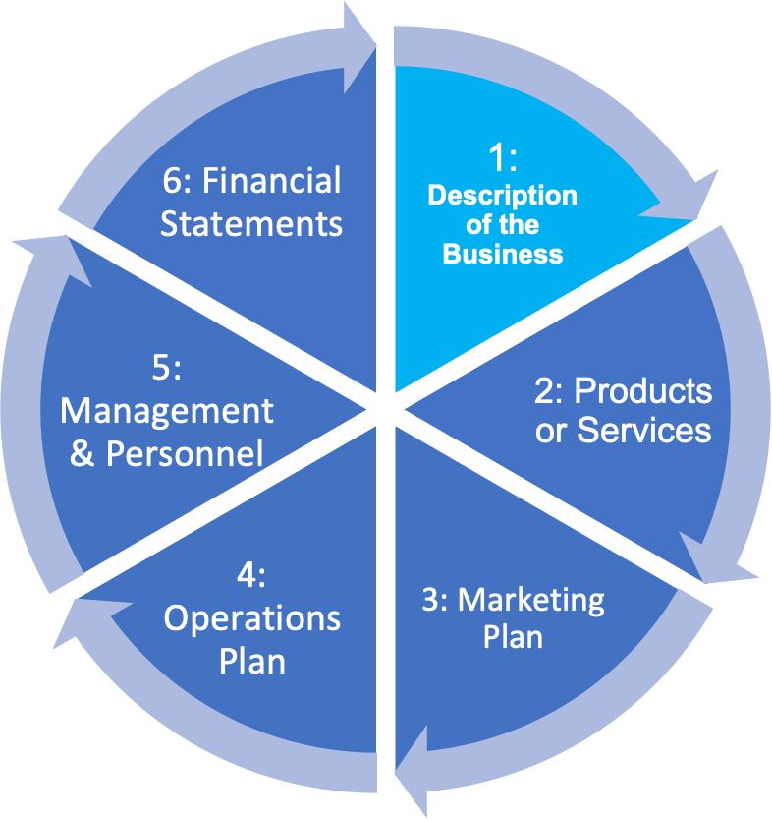
While writing a business plan can be time consuming, here are some tips to help you tackle the job:
- Do it in pieces: It'll be a few pages long. Don't stress about perfect sentences at first, just jot down your main points in each section for later review.
- Fill in all the sections: Potential partners want a clear picture of your business. Draft something and check for accuracy later.
- Show it to others: They might spot ideas or mistakes you missed (see above). Mentors, the SBDC, or the SBA can guide you.
- Do the Executive Summary LAST. Start with the Company Description and move on from there. We suggest this order:
- Company Description
- Products & Services
- Marketing Plan
- Operational Plan
- Management & Organizations
- Financial Forecasts
- Appendices
- Executive Summary
- Table of Contents
- Appendices

Here is a real-life example of the thought process that goes into writing a business plan:
Imagine you're building a lemonade stand! Here's what you need to do:
- Set Goals & Check the Market: First, decide how much lemonade you want to sell (your goal). Then peek around the park (analyze the market) to see if other kids are selling lemonade already (competition).
- Who Wants Lemonade? Figure out who might be thirsty and want to buy yours (target audience). Maybe it's kids playing on the swings, or grown-ups taking a walk. Think about any challenges too, like if it might rain (plan for challenges).
- More Than Just Lemonade? Maybe you could add cookies (identify opportunities) to sell with your lemonade!
- How Much Lemonade Do We Need? Figure out how many cups of lemonade you need to sell to make enough money to buy more lemons and sugar (calculate break-even point).
- Sell, Sell, Sell! Practice your best "Would you like some lemonade?" voice (pitch) to convince people to buy from you (secure resources).

Here are actual excerpts from a business plan using the company “MAT.”

Description of the Business
MAT Company (founded 2011) develops innovative rehabilitation equipment designed by therapists to help patients regain function. We focus on underserved areas, like bariatric rehabilitation, to improve patient outcomes.

Products or Services
The MAT table is a multi-functional manual or electric treatment and exercise table designed to address the specific needs of rehabilitation facilities. It offers a flexible solution that can be used for both therapeutic treatments and patient exercise routines. I envision several models of this
The unique components of the MAT table allow for bariatric patients to transfer on and off the table without fear of falling. The MAT has two main components; see Appendix 1 for pictures.
The body component will be 3 feet 8 inches and will slide on a steel frame.

Unique Selling Proposition
The only multi-function table designed specifically for safe and easy transfers of bariatric patients, improving rehabilitation outcomes. Our multi-function design ensures safe transfers and seamless transition between treatment and exercise, leading to a faster path to recovery.

Marketing Plan
Marketing will focus on pre-launch awareness through targeted social media and email campaigns, with direct outreach to rehab directors in small-to-medium clinics. We'll leverage promotional materials and digital marketing to drive brand recognition and website traffic.

Ownership and Management
A strong team supports MAT's development. We leverage expertise from a marketing consultant, accountant/bookkeeper, business advisor, SCORE mentor, and Western Michigan University's engineering program (in collaboration with SCALE Kalamazoo). An attorney is on retainer, and a patent application is filed. We partner with an engineering firm for prototype development. Expansion plans include hiring a COO and a distribution specialist.

Operations Plan
The MAT table is currently under development by the founder of Excellence in Rehabilitation (wholly owned), with a welder assisting in the process. The first prototype was successfully completed in August 2018, and estimates for the second iteration are being collected from engineering firms. By the end of 2019, the company aims to finalize a comprehensive 3-5 year business plan, complete the second prototype, and launch sales and marketing initiatives. Additionally, securing partners and funding will be a key focus area in the coming months.

Financial Statement (Summary of projections and profit and loss statement)
The estimated cost for building the fully electric MAT would be $X000-$X000. The selling price is anticipated to range from $X,000 to $XX.000. Generally pricing for these products range from $X000 to $XX,000.

Write your Executive Summary LAST
The Executive Summary is the most important part of your business plan. Often, it’s the only part that a prospective investor or lender reads before deciding whether or not to read the rest of your plan. It should convey your enthusiasm for your business idea and get readers excited about it, too.

Write your Executive Summary LAST, after you have completed the rest of the business plan. That way, you’ll have thought through all the elements of your startup and be prepared to summarize them.

The Executive Summary should briefly explain each of the below:
- An overview of your business idea (one or two sentences).
- A description of your product and/or service. What problems are you solving for your target customers?
- Your goals for the business. Where do you expect the business to be in one year, three years, five years?
- Your proposed target market. Who are your ideal customers?
- Your competition and what differentiates your business. Who are you up against, and what unique selling proposition will help you succeed?
- Your management team and their prior experience. What do they bring to the table that will give your business a competitive edge?
- Financial outlook for the business. If you’re using the business plan for financing purposes, explain exactly how much money you want, how you will use it, and how that will make your business more profitable.

After reading the Executive Summary, readers should have a basic understanding of your business, should be excited about its potential, and should be interested enough to read further. Limit your Executive Summary to one or two pages in total.

